Figure 1 map of 11 areas.

Need to overlay EVOS spill zone and make this prettier.

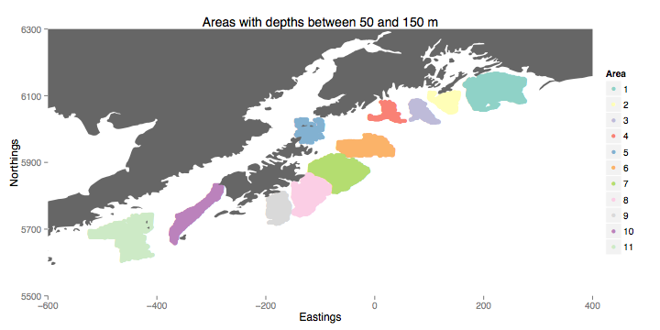

Fig. 2. Mean estimated CPUE for each of the 11 focal areas. Focal areas with known higher exposure to EVOS are in red. Remaining areas are in black. Vertical dashed bar shows EVOS. Second row shows the time-series for the three guilds. The third row shows the three diet groups and the fourth row shows the species grouped by recruitment interval categories.



Fig.2 Alternate. Same as figure 1 but mean centered (each time series with its mean subtracted). Easier to see patterns?



Fig. 3. Linear Trends… Areas hypothesized to be most affected by EVOS are shaded darkly, the marginal areas are lighter shading. Each row shows the community broken up based on guild, diet category, or length of time to recruitment to the trawl survey (short is <2 years; medium is 2-4 years; long is > 4 years).



Fig. 4. CV using the same groups as above.



Fig. 5 Ternary plot. Showing species composition of three main functional groups is similar across all of the areas.







Figure 6: (Top) Pairwise correlations between focal locations for total biomass for the period 1990-99. Red colors indicate positive correlations, blues indicate negative correlations and greys indicate approximate correlation of 0. (Bottom) Time-series of cross-correlations for total biomass using a nine-year moving window. Red line shows median cross-correlation among areas outside of the main EVOS spill (“Control”; areas 1 and 7-11). Green line shows median cross-correlation of all pairwise correlations in areas within the EVOS zone (“EVOS”, areas 2-6). Blue line shows median cross-correlation between areas within EVOS and the control ares (“EVOS-Control”).